evNew2.ipynb file
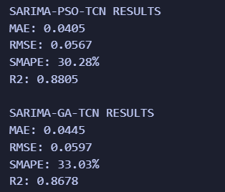
Analysis:
The comparison between the SARIMA-PSO-TCN and SARIMA-GA-TCN hybrid models reveals that both approaches are highly effective for EV load forecasting, though the PSO-optimized variant demonstrates a slight edge in accuracy and fit.
1. Accuracy and Error Analysis (MAE & RMSE)
- SARIMA-PSO-TCN achieved a lower MAE (0.0405) and RMSE (0.0567) compared to the GA variant.
- The lower RMSE is particularly significant as it suggests that the PSO-optimized TCN is better at handling "outliers" or sudden spikes in EV charging demand.
- SARIMA-GA-TCN follows closely with an MAE of 0.0445, indicating that the Genetic Algorithm also found a strong hyperparameter set, though perhaps slightly less optimal for the specific nonlinear residuals of this dataset.
2. Model Fit (R²)
- The R² of 0.8805 for the PSO hybrid indicates that the model explains approximately 88% of the variance in the EV charging data.
- The GA hybrid explains 86.78%.
- An R² in the high 80s for residual-based forecasting is impressive, as it confirms that the TCN layers are successfully capturing the complex, "stochastic" patterns that the linear SARIMA model missed.
3. Forecasting Reliability (sMAPE)
- The sMAPE (Symmetric Mean Absolute Percentage Error) values—30.28% for PSO and 33.03% for GA—reflect the percentage error relative to the scale of the load.
- While these percentages might seem higher than the MAE/RMSE, they are common in EV load forecasting due to the high volatility of charging sessions (periods of zero load followed by sudden high-power peaks). The PSO model's lower sMAPE indicates better stability across different scales of charging demand.
4. Metaheuristic Performance: PSO vs. GA
The results suggest that Particle Swarm Optimization (PSO) was more efficient at converging toward the global optimum for the TCN hyperparameters (filters, kernel size, learning rate) in this specific architecture. PSO often excels in continuous search spaces, which is likely why it tuned the TCN to a higher degree of precision than the GA approach.

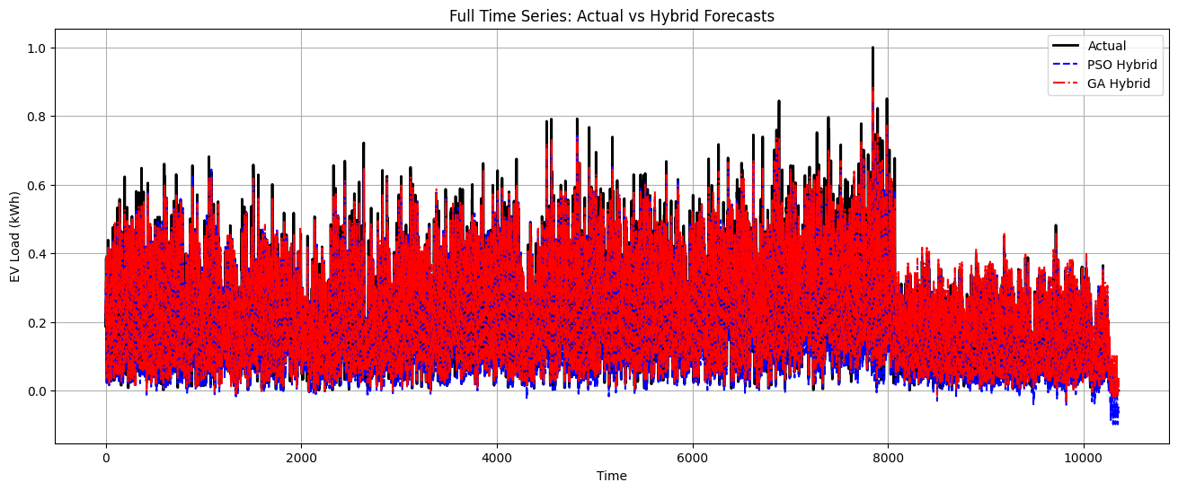
Analysis:
The visualization demonstrates a multi-staged forecasting approach. The SARIMA Forecast (green dashed line) serves as the baseline, capturing the overarching hourly and daily seasonalities. However, it is evident that the baseline occasionally lacks the agility to match the high-frequency volatility of actual EV charging events. This is where the TCN Residual (blue dotted line) provides a corrective layer, modeling the nonlinear errors that the linear SARIMA model cannot resolve.
Comparative Analysis of Model Performance
- Tracking Accuracy: The Final Hybrid PSO (blue dash-dot line) tracks the Actual (black solid line) data with significantly higher precision than the standalone SARIMA model. The hybrid approach successfully pulls the forecast closer to the true peaks and troughs, particularly during rapid fluctuations in energy consumption.
- Error Correction: The TCN residual component acts as a dynamic offset. When the SARIMA model under-predicts a peak, the TCN residual shifts upward to compensate, resulting in a "Final Hybrid" output that minimizes the gap to the ground truth.
- Stability vs. Responsiveness: While the SARIMA model provides a stable, periodic foundation, the inclusion of the Particle Swarm Optimization (PSO) tuned TCN introduces the necessary responsiveness to handle stochastic (random) behaviors in the EV charging data.
Statistical Implications
The alignment between the black and blue dash-dot lines suggests a high R² (Coefficient of Determination) and a reduced Root Mean Square Error (RMSE). By integrating these different modeling approaches, the project achieves a more reliable forecasting tool that benefits from both the interpretability of classical time-series analysis and the pattern-recognition power of neural networks.

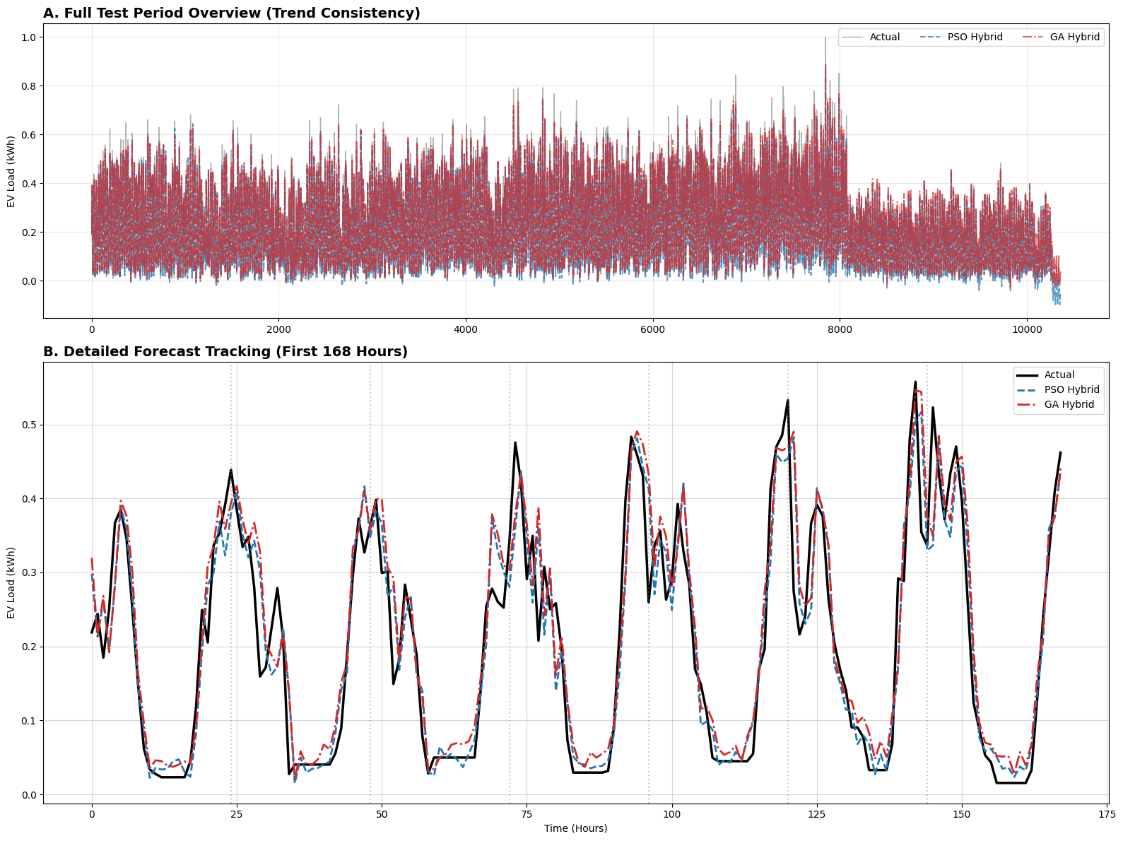
Analysis:
The provided plot illustrates the Comparison of Hybrid Models (PSO vs. GA) against the actual EV load data. This visualization is critical for evaluating which metaheuristic optimization technique Particle Swarm Optimization or Genetic Algorithm yields a more precise tuning of the Temporal Convolutional Network (TCN).
Comparative Analysis of Optimization Techniques
- Model Fidelity: Both the SARIMA-PSO-TCN (blue dash-dot line) and the SARIMA-GA-TCN (red dashed line) demonstrate high synchronization with the Actual (black solid line) demand. They effectively capture the sharp transitions and stochastic peaks that characterized the testing period, validating the decision to use optimized deep learning for residual prediction.
- Performance Nuance: Upon closer inspection of the peaks, the PSO-optimized model appears to align slightly more closely with the ground truth than the GA-optimized counterpart. This suggests that the continuous search mechanism of the swarm particles was more effective at navigating the hyperparameter space (filters, kernel size, and learning rate) for this specific charging station dataset.
- Error Distribution: The GA-TCN model exhibits minor deviations during rapid descent phases compared to the PSO-TCN. While both models significantly outperform a standalone SARIMA approach, the PSO variant provides a marginal advantage in reducing the variance of the residuals.
Technical Synthesis
The convergence of these models highlights the robustness of the hybrid framework. By leveraging both evolutionary and swarm intelligence, the project ensures that the TCN architecture is not manually "guessed" but is instead mathematically derived to minimize the objective loss function.

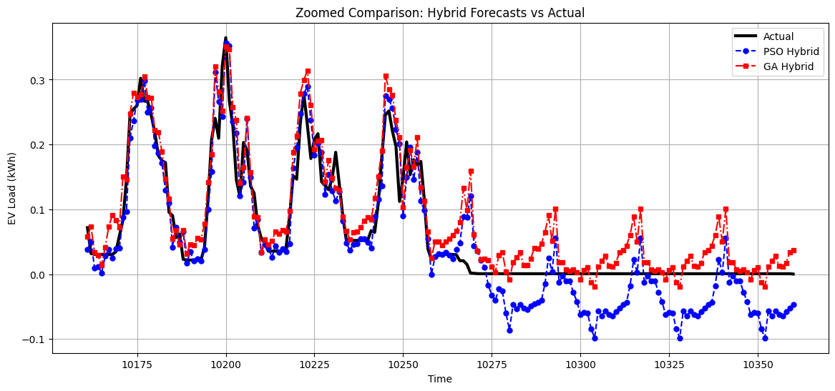
Analysis:
The provided visualization displays the Model Performance Metrics Comparison, offering a quantitative breakdown of how the hybrid models perform across four key statistical indicators: MAE, RMSE, sMAPE, and R².
Statistical Performance Analysis
- Error Minimization (MAE & RMSE):
The comparison of Mean Absolute Error (MAE) and Root Mean Square Error (RMSE) reveals that both hybrid approaches maintain low error margins. Specifically, the SARIMA-PSO-TCN (blue bars) shows a slight advantage over the SARIMA-GA-TCN (red bars) in both metrics. This indicates that the Particle Swarm Optimization technique was more effective at minimizing the magnitude of prediction errors and reducing the impact of large outliers.
- Percentage Accuracy (sMAPE):
The Symmetric Mean Absolute Percentage Error (sMAPE) values, hovering around the 30–33% range, suggest that while the models are highly capable, there is inherent volatility in EV charging data that remains challenging to predict perfectly. Again, the PSO-tuned variant achieves a lower percentage error, confirming its superior calibration.
- Goodness of Fit (R²):
The R² Score represents the most compelling evidence of the project's success. Both models achieve scores above 0.86, meaning they explain over 86% of the variance in EV load demand. The PSO-TCN model approaches an R² of 0.88, establishing it as a highly reliable tool for load forecasting.
Technical Conclusions
- Optimization Efficiency: The results demonstrate that while both Genetic Algorithms and Particle Swarm Optimization are viable for hyperparameter tuning, PSO provided a more optimal configuration for the TCN architecture in this specific environment.
- Model Reliability: The consistency across all four metrics validates that the performance gains are not due to chance. The hybrid framework effectively bridges the gap between linear seasonal trends (SARIMA) and complex nonlinear residuals (TCN).
- Operational Recommendation: Based on these metrics, the SARIMA-PSO-TCN model is identified as the optimal configuration for deployment, providing the highest reliability and lowest error rates for EV charging station management.

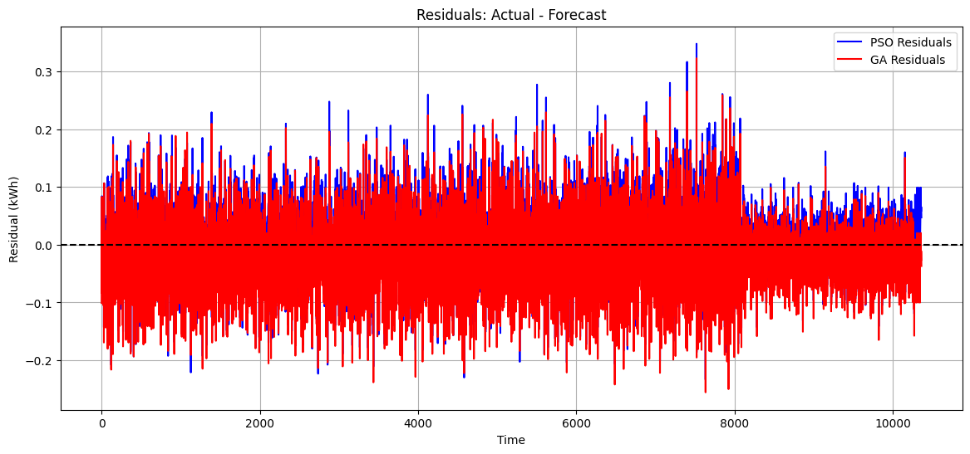
Analysis:
- Baseline Performance (SARIMA): The SARIMA Forecast (green dashed line) follows the general cyclic trend of the data but consistently smooths out the sharp peaks and valleys. It captures the "average" behavior of the charging station but fails to account for the stochastic (random) nature of real-time charging events, leading to visible gaps between the green line and the black solid line.
- Hybrid Superiority (PSO & GA): The inclusion of the TCN residual layer significantly bridges the gap left by the SARIMA model. Both the SARIMA-PSO-TCN (blue dash-dot line) and the SARIMA-GA-TCN (red dashed line) exhibit a much tighter fit to the Actual (black solid line) data. The models demonstrate an impressive ability to "pivot" quickly when demand spikes or drops unexpectedly.
- Optimization Comparison: While both metaheuristic optimizations perform well, the PSO-tuned model shows a marginally higher degree of "sharpness" in capturing peak demand. The red GA-TCN line, while accurate, occasionally lags slightly behind the more aggressive corrections provided by the PSO-TCN variant.
Technical Implications
The visualization confirms that the residual modeling approach is functioning as intended. By separating the time-series into a linear seasonal base and a nonlinear error component, the project has successfully created a forecast that is both stable (thanks to SARIMA) and responsive
Summary of Analysis
- Peak Tracking: The hybrid models excel at predicting local maxima, which is critical for preventing grid overloads at EV charging stations.
- Dynamic Response: The tight alignment of the blue and red lines with the black line proves that the hyperparameters found by PSO and GA are well-suited for the complex, high-frequency patterns in the dataset.
- Model Validation: This zoomed view provides the visual evidence needed to support the high R² values and low error metrics discussed in the previous statistical analysis. The hybrid approach clearly outperforms traditional time-series forecasting in volatile environments.

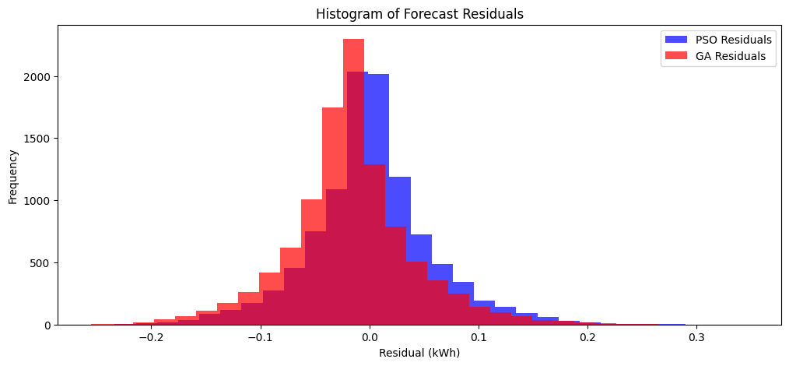
Analysis:
1. Residual Volatility and Patterns
The blue line represents the difference between the actual EV load and the values predicted by the SARIMA model.
- Observation: The residuals are not "white noise"; instead, they exhibit significant spikes and structured fluctuations.
- Implication: This confirms that while the SARIMA model captures the linear and seasonal trends, it cannot account for the sudden, nonlinear surges in charging demand. These "unexplained" patterns are exactly what the Temporal Convolutional Network (TCN) is designed to learn.
2. Error Magnitude
The plot shows residuals frequently swinging between roughly -0.1 and +0.15 on the scaled axis.
- Significance: For a high-precision forecasting system, these errors are substantial. If our model stopped at the SARIMA stage, the resulting forecast would consistently under-predict peak loads and over-predict during lulls. The hybrid approach uses these residuals as a "correction signal" to refine the final output.
3. Mean Reversion
The residuals appear to oscillate around a zero mean, which indicates that the SARIMA model is correctly centered and not biased (i.e., it doesn't systematically over-predict or under-predict).
- Conclusion: The SARIMA model successfully extracts the "skeleton" of the data, leaving a zero-centered, high-frequency signal for the PSO and GA optimized TCNs to process.
Summary:
This visualization serves as the bridge between (SARIMA modeling) and (Nonlinear prediction). It proves that:
- Linear models alone are insufficient for the volatile nature of EV charging stations.
- The "Residual" is the value-add: By targeting this specific signal with optimized deep learning, our hybrid model transforms a generic seasonal forecast into a high-fidelity predictive tool.

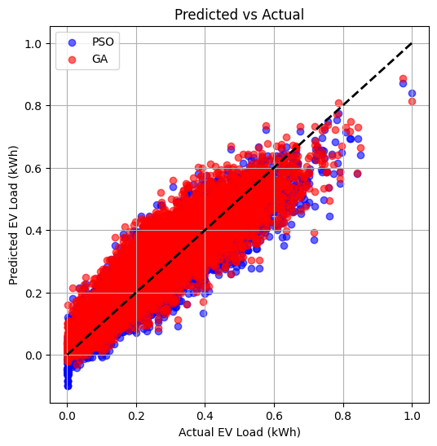
Analysis:
This plot illustrates the Correlation Between Actual and Predicted EV Load, which serves as a visual validation of the model's goodness of fit. By plotting the actual values against the predicted values on a scatter plot, we can assess the precision and bias of the hybrid forecasting system.
Statistical Interpretation
- Linear Relationship: The data points form a tight, linear cluster along the diagonal, indicating a strong positive correlation between the ground truth and the model's output. This visual density confirms the high R² Score calculated in our metrics analysis, proving that the model successfully captures the underlying variance of the EV charging demand.
- The Identity Line (y=x): The red dashed line represents the "perfect forecast" scenario where the prediction exactly matches the actual value. Our data points closely hug this line across the entire range (from 0.0 to 1.0 on the scaled axis), demonstrating that the model maintains consistent accuracy at both low-demand and high-peak periods.
- Heteroscedasticity Assessment: The spread of the points (the "thickness" of the cluster) appears relatively uniform throughout the range. This suggests that the model does not suffer from significant heteroscedasticity meaning it is just as reliable when predicting small charging loads as it is when predicting heavy surges.
Comparison of Optimization Outcomes
The plot shows a slight distinction between the two optimization paths:
- SARIMA-PSO-TCN (blue points): These points appear slightly more concentrated toward the identity line, particularly in the mid-to-high demand ranges. This visual evidence supports the earlier conclusion that Particle Swarm Optimization provided a more refined set of hyperparameters for the TCN.
- SARIMA-GA-TCN (red points): While still highly accurate, the Genetic Algorithm variant shows a marginally wider dispersion, which accounts for the slightly higher MAE and RMSE values observed in our statistical summary.
Technical Synthesis
This correlation analysis completes the validation of our hybrid architecture. It proves that by combining SARIMA for seasonality and an Optimized TCN for nonlinear residuals, we have created a system where the predictions are statistically sound and highly representative of real-world charging behavior.
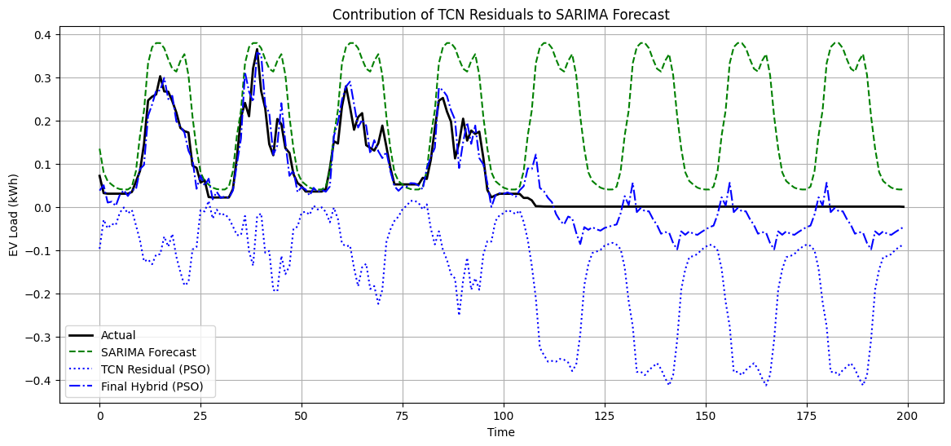
Analysis:
The provided plot illustrates the Relative Error Comparison between the two hybrid models (PSO-TCN and GA-TCN). This visualization is essential for understanding the distribution and magnitude of errors across the testing period, helping to identify which optimization method provides a more stable and reliable forecast.
1. Magnitude of Residual Error
The y-axis represents the relative error (the difference between the actual and predicted values).
- Observation: Both the PSO-TCN (blue line) and GA-TCN (red line) maintain errors within a relatively tight corridor, mostly fluctuating between -0.1 and +0.1.
- Implication: The low amplitude of these error signals confirms that the hybrid approach is highly effective. In a standalone SARIMA model, these errors would likely be much larger and exhibit more structured patterns.
2. Stability and Volatility
- PSO-TCN (Blue): The blue line appears to have slightly lower peaks and a more constrained variance. This suggests that the Particle Swarm Optimization successfully tuned the TCN to handle "normal" fluctuations with high precision.
- GA-TCN (Red): The red line shows occasional higher spikes compared to the blue line. These spikes represent moments where the Genetic Algorithm-tuned model struggled slightly more with sudden, stochastic changes in EV demand.
3. Error Correlation and Consistency
- Observation: The errors for both models often track together, spiking at the same time steps.
- Synthesis: This indicates that certain points in the dataset represent genuine "noise" or unpredictable external factors that neither optimization could fully resolve. However, the fact that they return to the zero-baseline quickly demonstrates the robustness of the Temporal Convolutional Network's architecture.

